Produce acceptors report and include non-acceptors
Meetings: Reece

Setup:
- Keystone
- Magnifying glass
- Type company name, double click and select
- Select corporate action events (cash offer)
- Select acceptors reports
- Click to include non-acceptors

Error:
After attempting to run the acceptors report and include the non-acceptors, nothing would happen for a minute then an error box would be displayed.
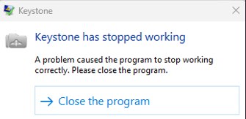
Reason:
The Stored procedure called by keystone when run on its own took 10 minutes to return any data, by which point keystone assumed it timed out and threw the above error, or on my own machine the application crashed. The source of the long execution time was a line in the stored procedure spxCAReports, which summed each holdings quantity. Considering there are 300,000 + for this company that’s what was taking so long to execute.

Solution:
The lines in the stored procedure that caused this long run time were replaced with the functions funcRegister(stockID), which returns latest holding for each holder, and funcRegisterAsAt(stockID, date), returns holding for each holder for x date. This took 10 seconds to execute as opposed to the 10 minutes of the previous commands.

